**Id code:** 19CM029  **Name:** Dhiraj Jagtap **Sem:** 5th

**Practical No: 6**

**Aim:** Write a PHP program to

a) Inherit members of super class in subclass.

b) Create constructor to initialize object of class

by using object-oriented concepts

**Procedure:**

1. Inherit members of super class in subclass.

**Theory:**

The parent class is also called a base class or super class. And the child class is also known as a derived class or a subclass. To define a class inherits from another class, you use the extends keyword.

**Program:**

<?php

class First{

    protected $myvar = "First Class";

}

class Second extends First{

 public $myvar = "Second Class";

    function __construct(){

        echo $this -> myvar;// here I want to access the $myvar of super class

    }

}

$obj = new Second();

 ?>

**Output:**

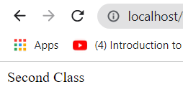

**b) Create constructor to initialize object of class**

**Theory:**

When you create an object, you are creating an instance of a class, therefore "instantiating" a class. The new operator requires a single, postfix argument: a call to a constructor. The name of the constructor provides the name of the class to instantiate. The constructor initializes the new object.

**Program:**

<?php

class student{

    var $stud_id;

    var $stud_name;

    function __construct($stud_id,$stud_name){

        echo "student Id code: ".$stud_id."<br>";

        echo "student Name: ".$stud_name;

        }

}

$dhiraj = new student('19CM029','Dhiraj');

?>

**Output:**

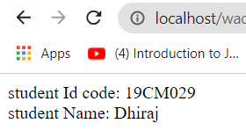

**Simple function**

**Theory:**

It’s very easy to create your own PHP function. Suppose you want to create a PHP function which will simply write a simple message on your browser when you will call it. Following example creates a function called write Message () and then calls it just after creating it.

Note that while creating a function its name should start with keyword **function** and all the PHP code should be put inside {and} braces as shown in the following example below −

**Program:**

<?php

// This is a Simple function

function under_age(){

    echo "You Are Under Age";

}

$age=16;

if ($age<18){

    under_age();

}

?>

**Output:**



**Parametrized Functions**

**Theory:**PHP gives you option to pass your parameters inside a function. You can pass as many as parameters your like. These parameters work like variables inside your function. Following example takes two integer parameters and add them together and then print them.

**Program:**

<?php

function fullname($name,$fathername,$surname){

    echo "Full_name: ".$surname.$name.$fathername;

}

$a=" Dhiraj ";

$b="Madhukar ";

$c="Jagtap";

fullname($a,$b,$c);

?>

**Output:**

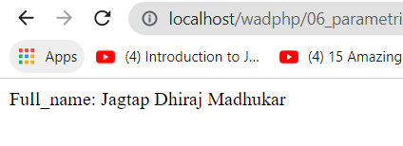

**Conclusion:** hence, we have seen the difference between Simple Function and Parameterized function.